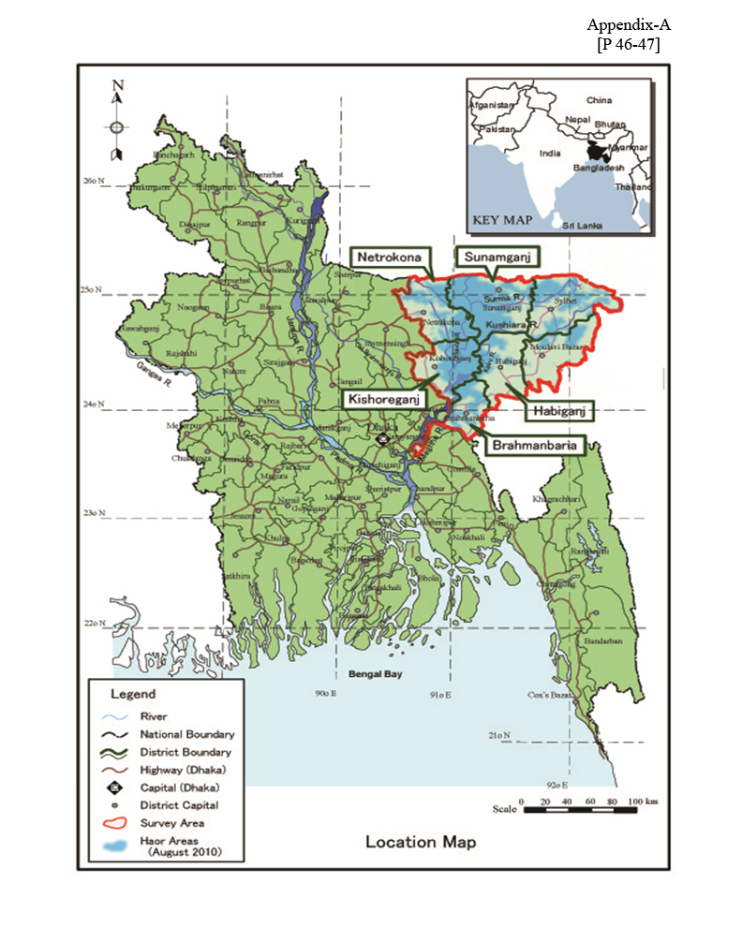

P - 46

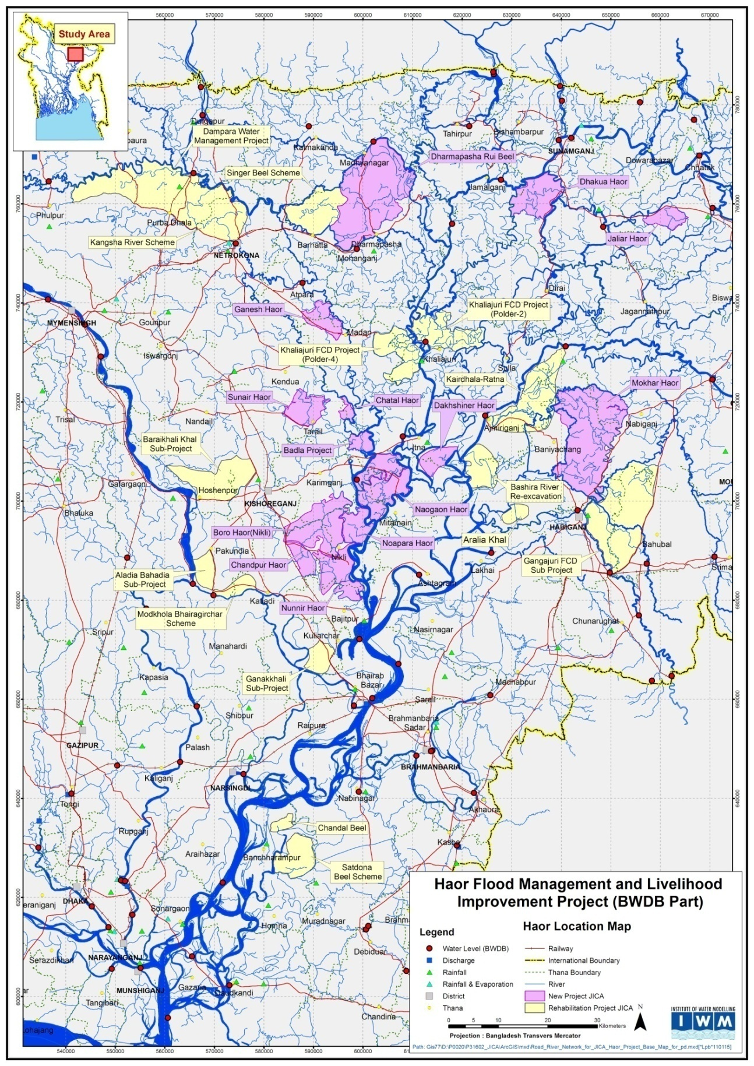

*Source: IWM May 2015*

Figure 1: Location of Proposed New and Rehabilitation Haor Sub-projects.

P - 47